
Artificial intelligence
(LAB)


Submitted By:
Name: Maira
Roll No: 249
Section: BSAI-3D

Submitted To:
Sir Rasikh

Task 1: PEAS Specifications
1. Delivery Robot
A delivery robot is designed to collect and deliver items from one location to another. It uses sensors to observe its surroundings and selects actions to complete deliveries safely.
PEAS Component:

Performance: | On-time delivery, safety, correct delivery, low energy consumption.
Environment: |  | Campus roads, buildings, students, pedestrians, obstacles and weather.
Actuators: |  | Wheels, motors, brakes, speaker and delivery compartment lock.
Sensors: |  | Camera, GPS, distance sensors, obstacle sensors and battery monitor.
Constraint:
The robot should deliver items on time, but speed should not be its only priority. It must avoid accidents and follow a safe route, even if delivery takes longer.
Operational Assumptions:
The robot operates within a university campus. It has access to GPS, cameras and obstacle sensors. It can move, stop and deliver items but cannot control traffic or remove obstacles.

2. LLM-Based Student-Support Agent
An LLM-based student-support agent helps students by answering questions about courses, assignments, university rules and study-related problems. It uses language understanding to provide relevant responses.

PEAS Component | Description
Performance | Correct answers, helpful responses, quick replies and student satisfaction.
Environment | Students, university courses, study materials, FAQs and university policies.
Actuators | Text responses, links to study resources, reminders and tool-based information retrieval.
Sensors | Student questions, uploaded documents, course information and available university data.

Constraint / Trade-off:
The agent should provide answers quickly, but accuracy is more important than speed. It should not give unsupported information just to satisfy the student.

Operational Assumptions:
The agent uses an LLM to understand and respond to student questions. It can access approved course materials, university FAQs and uploaded documents through available tools. It does not have direct access to private student records or the authority to change university results.
===============================================================

Task 2: Environment Classification
An environment can be classified according to how much information an agent can observe and whether its actions have predictable results.

1. Delivery Robot:
Observability: Partially Observable
The robot cannot observe everything around it. For example, its camera may not detect an obstacle behind another object, and it may not know what a pedestrian will do next.
Nature: Stochastic
The results of its actions are not always predictable. For example, a person may suddenly cross its path, or weather conditions may affect its movement.
2. LLM-Based Student-Support Agent
Observability: Partially Observable
The agent only knows the information provided by the student and the data available through its tools. It cannot directly know the student's actual understanding or information that has not been shared.
Nature: Stochastic
The same question can sometimes produce different responses. The agent may also misunderstand a question or provide an incorrect answer.
Comparison with a Simplified Simulator
In a simplified simulator, both systems can be designed with fixed inputs and predictable outcomes. For example, a delivery robot may follow predefined routes, while a student-support agent may answer from a fixed set of questions and answers.
However, real-world environments are more complex and contain uncertainty. Therefore, both systems are classified as partially observable and stochastic under the real-world assumptions described above.

===============================================================

Task 3: Stateful Classroom Agent

1. Code Explanation:
In this task, I extended the classroom agent to remember its previous operating mode. The agent takes temperature and room occupancy as input and selects a suitable mode.
- If the room is empty, it selects ECO mode.
- If the temperature is above 26°C, it selects COOL mode.
- If the temperature is below 20°C, it selects WARM mode.
- Otherwise, it selects IDLE mode.
The agent also checks its previous mode. If the new mode is the same, it does not send the command again. If the mode changes, it sends a new command.
2. Testing and Results
I tested the program with different temperatures and room conditions to check whether it selects the correct mode and avoids repeating commands.
Step | Previous Mode | Temperature | Occupied |  | Target Mode | Command
1 | None | 29 |  | True | COOL | Send
2 | COOL | 29 |  | True | COOL | No command
3 | COOL | 20 |  | True | IDLE | Send
4 | IDLE | 26 |  | True | IDLE | No command
5 | IDLE | 19 |  | True | WARM | Send
6 | WARM | 29 |  | False | ECO | Send
7 | ECO | 29 |  | False | ECO | No command
8 | ECO | 24 |  | True | IDLE | Send

Result: All eight test cases worked correctly. The agent selected the expected modes and avoided sending the same command repeatedly.
3. Program Output
The program was successfully executed in VS Code. It displayed the previous mode, temperature, occupancy, target mode and command status for each test case.
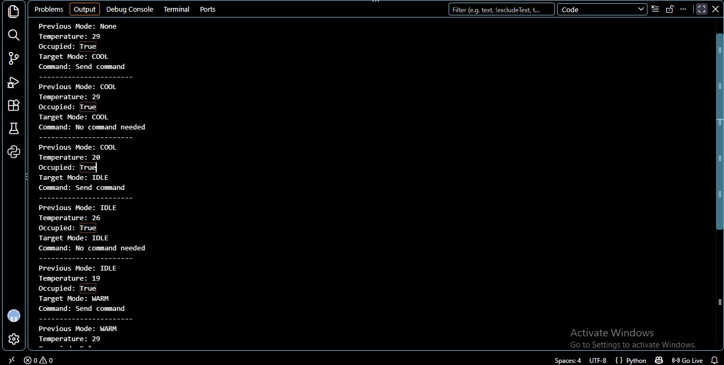

4. Difference Between Reflex Agent and Stateful Agent
A reflex agent makes decisions using only the current input. It does not remember its previous actions, so it may send the same command repeatedly.
A stateful agent remembers its previous mode and compares it with the new mode before sending a command.
For example, when the room is occupied and the temperature stays at 29°C, the reflex agent selects COOL every time. However, the stateful agent sends the COOL command once and does not send it again if the mode remains unchanged.
Conclusion: The stateful agent is more efficient because it remembers the previous mode and avoids unnecessary repeated commands.
5. Edge Case and Limitations
One edge case occurs when the temperature is exactly 20°C or 26°C. In both situations, the agent selects IDLE mode because the program uses greater-than and less-than conditions.
Another case occurs when the room becomes empty. The agent selects ECO mode even if the temperature is high because occupancy has priority.
The program has some limitations. It uses fixed inputs and does not handle sensor errors or changing weather conditions. It also does not control actual classroom equipment.
6. Reflection
1. What did I learn today?
I learned how an intelligent agent takes input, makes decisions and remembers its previous mode.
2. How can I apply this in a real AI system?
This type of agent can be used in smart classrooms to manage cooling and reduce unnecessary energy use.
3. What failed or surprised me?
I noticed that the agent could avoid repeating the same command by remembering its previous mode.
4. What would I do differently next time?
I would try to improve the agent by adding sensor-error handling and better temperature control.
7. Responsible Practice
The agent should maintain a comfortable classroom environment while avoiding unnecessary energy use. Student comfort and safety should always be considered along with energy savings.
==============================================================================================================================

